**Molecular Biology and Biochemistry**

(Exam: 100 points, 6 at 82 points – 4 at 50 points. You must draw structures and make simple calculations besides knowing everything by heart.  
Ella: [muelleel@student.ethz.ch](mailto:muelleel@student.ethz.ch) => send pdf and https://www.edx.org/course/principles-biochemistry-harvardx-mcb63x-1)

**Notes chapter 15**

The reactive site of nicotinamide adenine dinucleotide is the nicotinamide ring. It is abbreviated NAD+ or NADP+ if it has a phosphate. It is used during the electron transport chain to O2. It is not an H binding to NAD+ but a hydrine (H-, “H minus”).

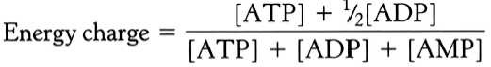

If energy charge = 1, then all ATP. If energy charge = 0, all AMP. If energy charge is high, then ATP anabolic pathways are inhibited and ATP catabolic pathways are stimulated. If energy is low, anabolic ATP pathways are stimulated and ATP catabolic pathways are inhibited and alternative pathways are activated during ATP regeneration (for example through AMP of F-2,6-P in glycolysis).

**Phosphorylation potential = [ATP]/[ADP]+[P_i]**

This formula is directly related to the free energy storage of ATP.

An enzyme will remain inactive if only ATP is bound to it. Actually, the ATP-Mg2+ (or Mn2+) complex is the true activating substrate for an enzyme. Thus, an enzyme will only exhibit activity when Mg2+ is present.

**PART 3**

Must know this by heart with structures:

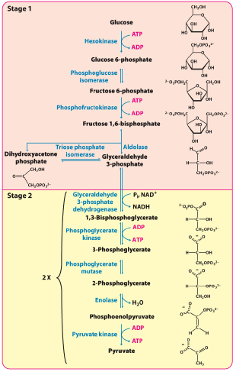

Phase two of glycolysis begins when a compound with high phosphoryl transfer potential, 1, 3-bisphosphoglycerate, is generated by the oxidation of GAP in a reaction catalyzed by glyceraldehyde 3-phosphate dehydrogenase.

The formation of glyceraldehyde 1,3-bisphosphate can be thought of as occurring in two steps: the highly exergonic oxidation of carbon 1 in GAP to an acid, and the highly endergonic formation of glyceraldehyde 1, 3-bisphosphate from the acid. These two reactions are linked by the formation of an energy-rich thioester in the active site of glyceraldehyde 3-phosphate dehydrogenase.

1.11.2017

**Gluconeogenesis**

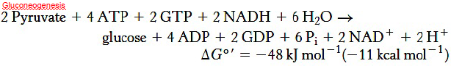

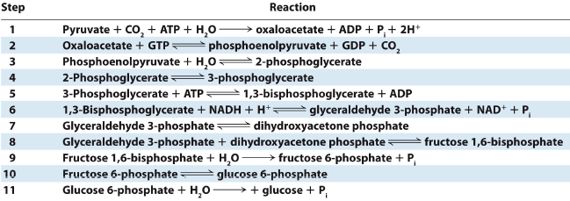

**Classical Cori cycle**

In muscle: Glucose – pyruvate (yields 2 P) – lactate.  
In liver follows also: Lactate – pyruvate (takes 6 P) – glucose.

I must know these things by heart for the **pentose pathway**:

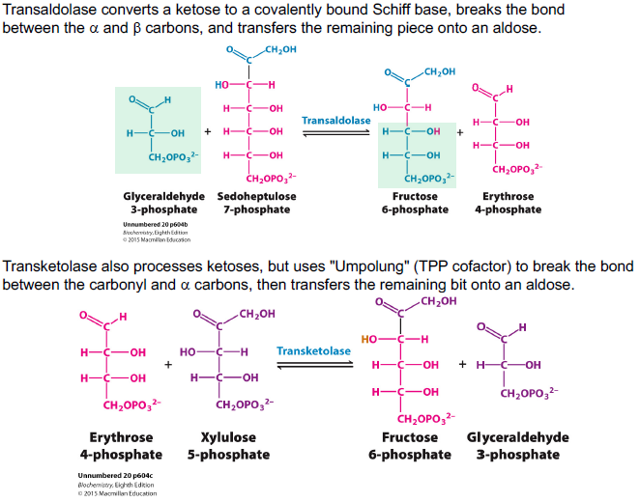

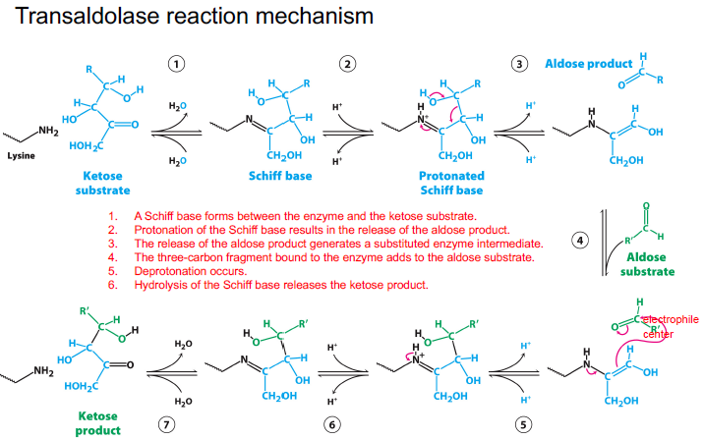

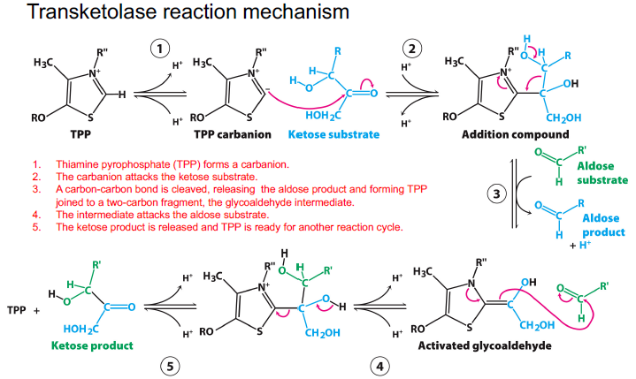

**Pentose phosphate pathway**

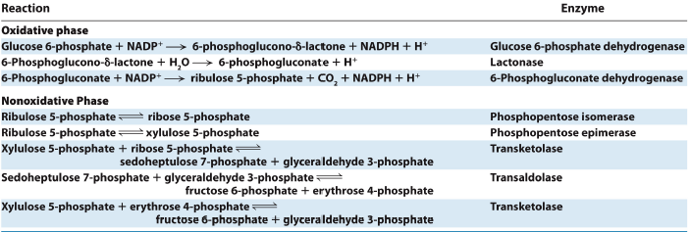

**Modes of the pentose phosphate pathway**

The flow of glucose-6-phosphate depends on the need for NADPH, ribose-5-phosphate, and ATP. The pentose phosphate pathway can operate in distinct modes that result from various combinations of the oxidative phase, the nonoxidative phase, glycolysis, and gluconeogenesis.

**Mode 1**: Ribose-5-phosphate needs to exceed the needs for NADPH. 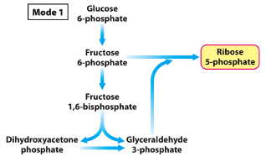

**Mode 2**: The NADPH and ribose-5-phosphate needs are balanced.

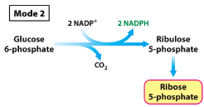

**Mode 3**: More NADPH is needed than ribose 5 - phosphate.

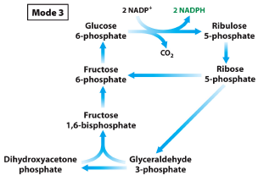

**Mode 4**: NADPH and ATP are both required.

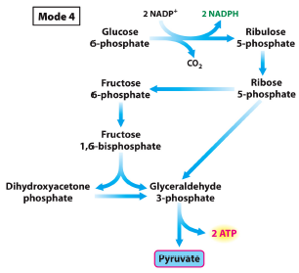

**Tissues with active pentose phosphate pathway**: adrenal gland (steroid synthesis), liver (fatty acid and cholesterol synthesis), testes (steroid synthesis), adipose tissue (fatty acid synthesis), ovary (steroid synthesis), mammary gland (fatty acid synthesis), red blood cells (maintenance of reduced glutathione).

**Amino acid degradation**

3 steps in degradation of amino acids: removal of alpha-amino group; insertion of nitrogen into urea; transformation of the carbon network

There are two pathways to degrade amino acids: deamination and transamination.

**Deamination**

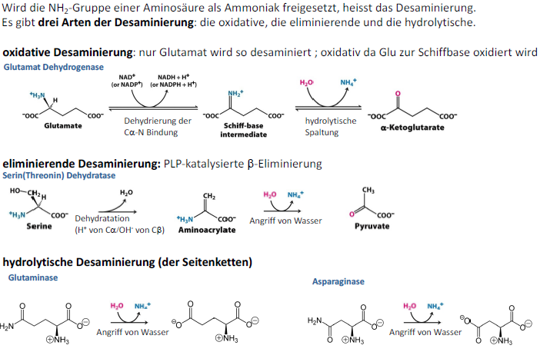

**Transamination**

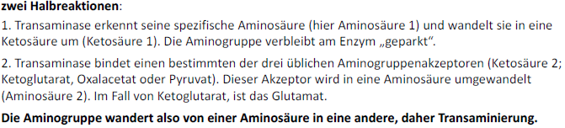

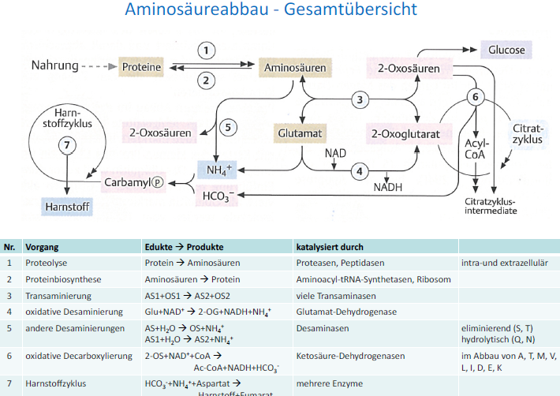

29.11.2017

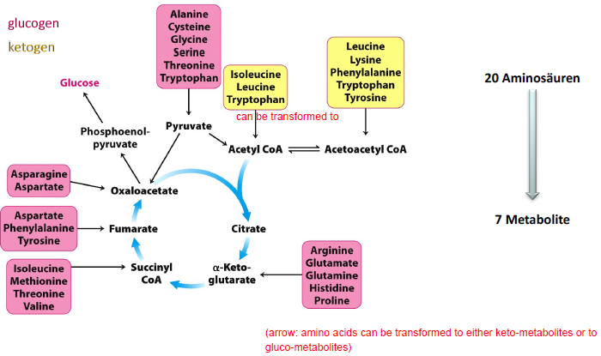

There are six different systems for amino acid biodegradation depending on the structure of the amino acids:

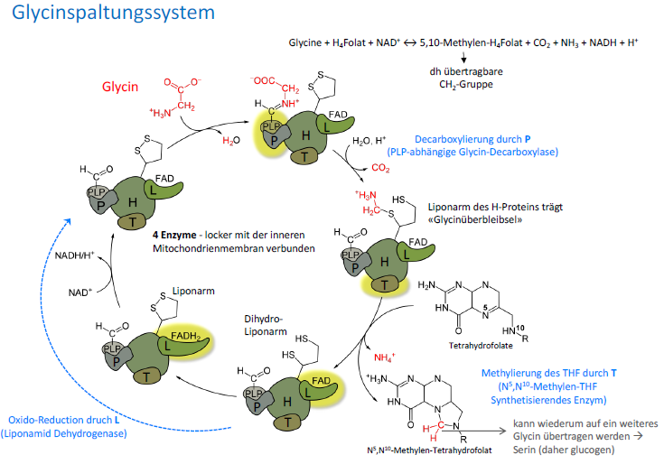

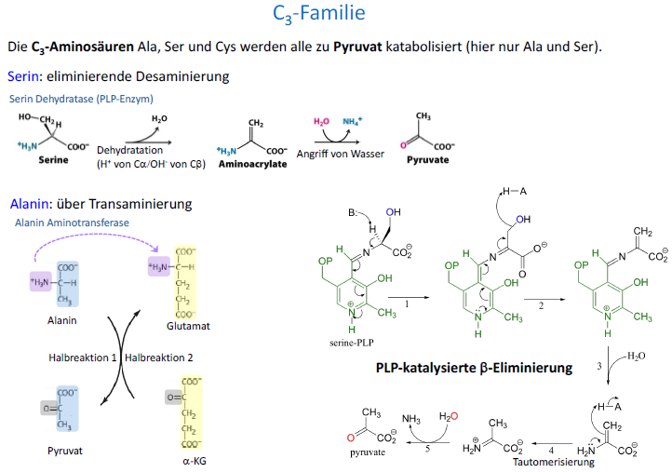

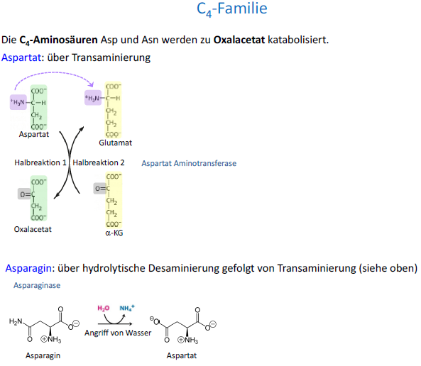

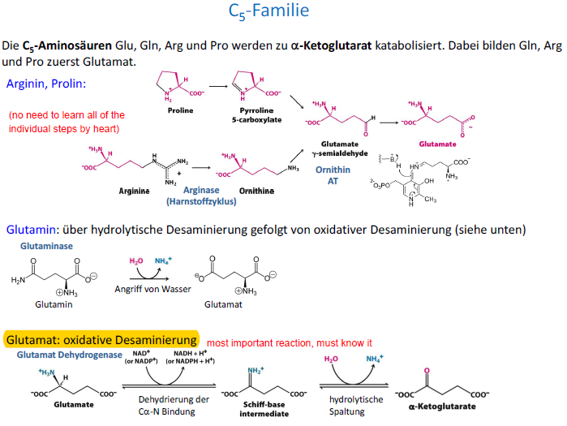

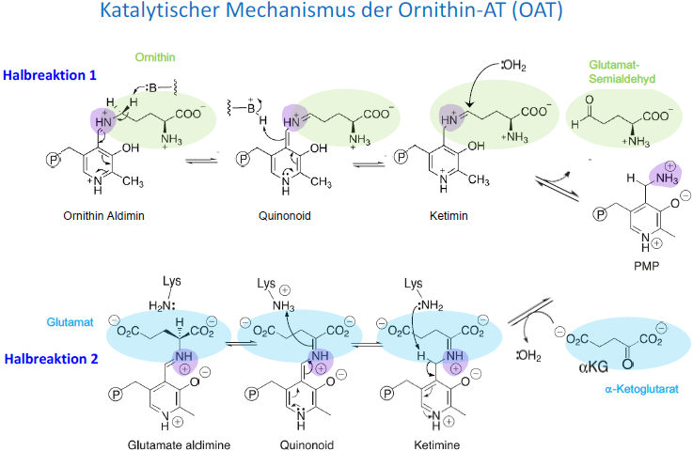

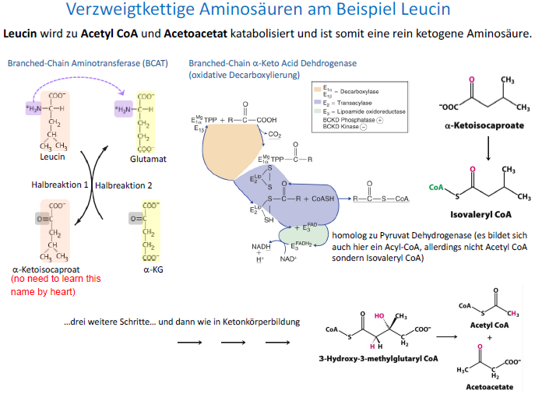

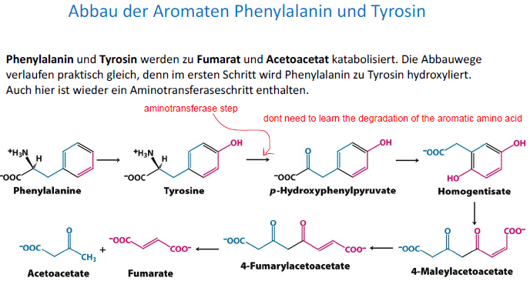

**Amino acid biosynthesis**

